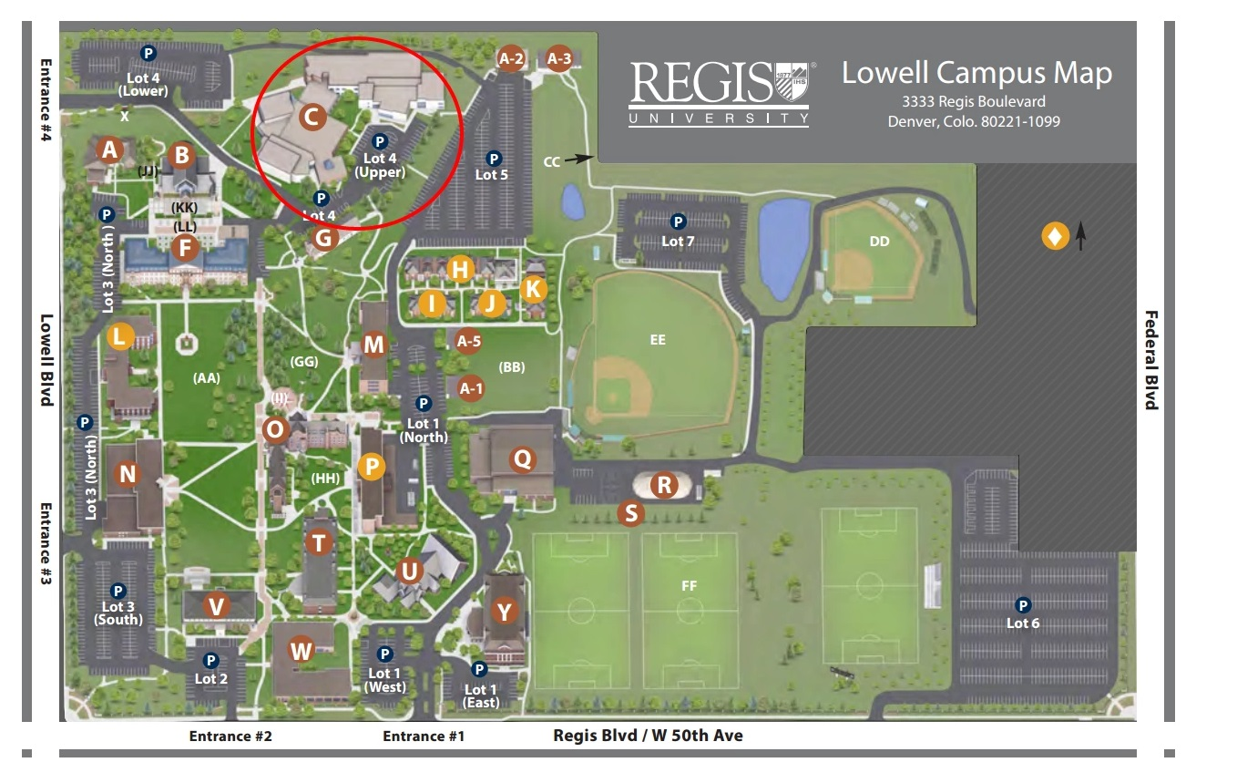
Claver Hall is noted by the red circle. Parking is available in Lot 4 upper or lower lot. Parking passes will be available at the conference registration desk located at the banquet room.

